CIS 581

Rishabh Jain

1/25/2018

**LAB 2**

/*Q1*/

SELECT VendorName, VendorCity, VendorState

FROM AP.dbo.Vendors;

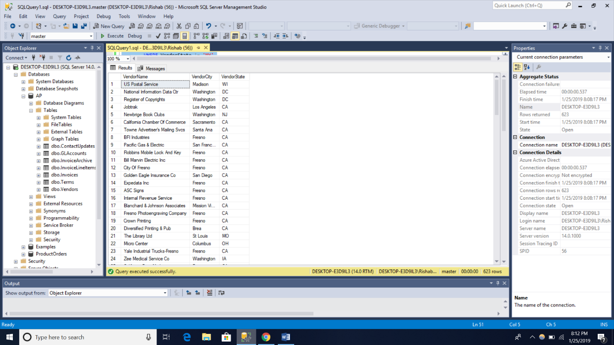

(122 rows affected)

/*Q2*/

SELECT InvoiceNumber AS Number, InvoiceTotal AS Total,

PaymentTotal + CreditTotal AS Credits

FROM AP.dbo.Invoices

WHERE InvoiceTotal <= 200;

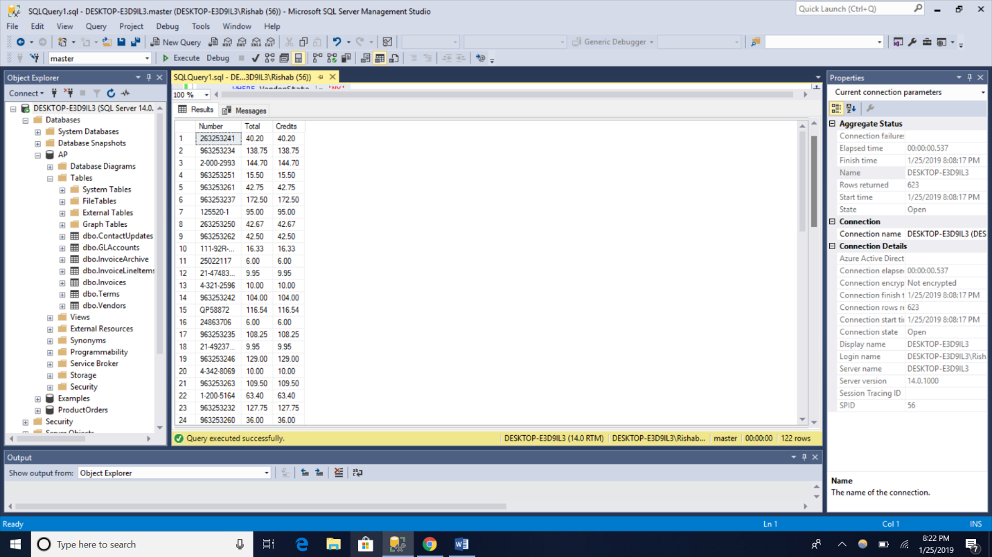

(65 rows affected)

/*Q3*/

SELECT VendorContactLName + ',' + VendorContactFName AS [Full Name]

FROM AP.dbo.Vendors

ORDER BY VendorContactLName ASC;

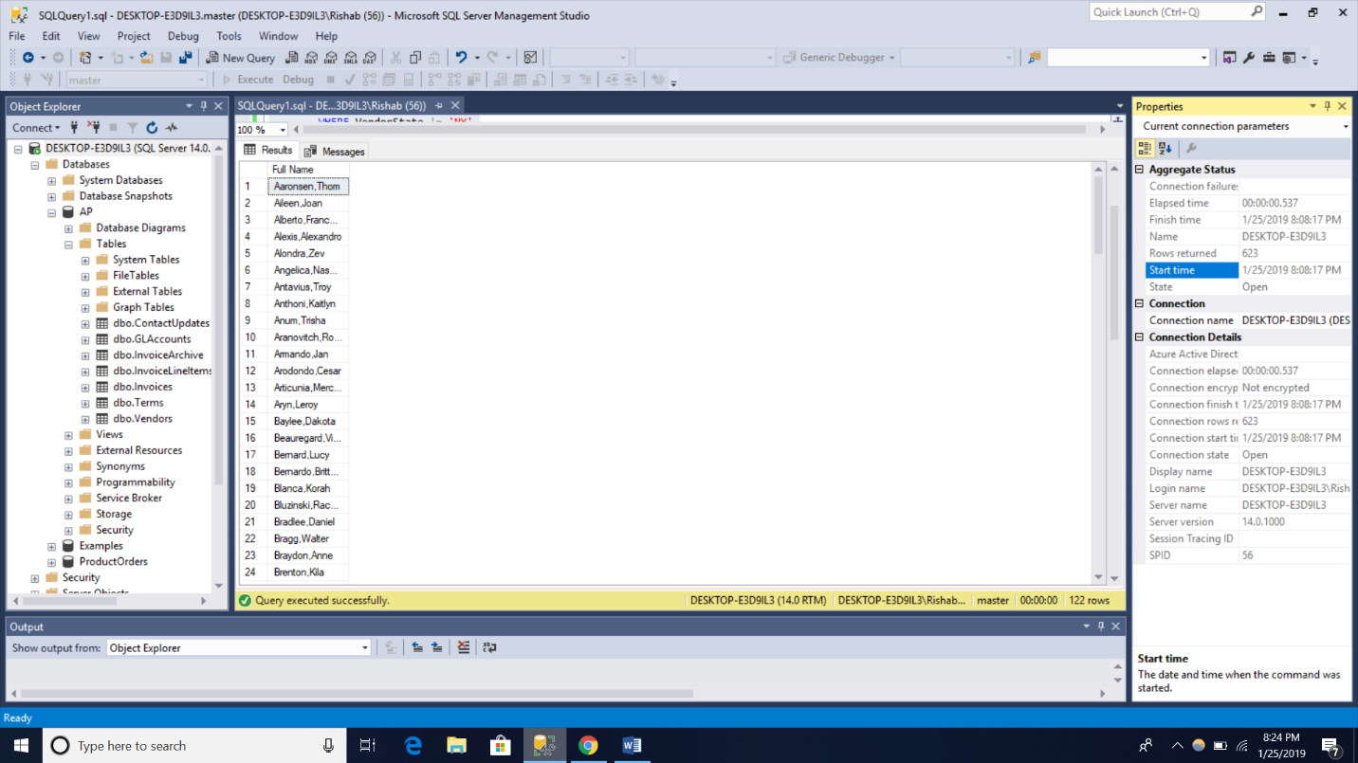

(122 rows affected)

/*Q4*/

SELECT *

FROM AP.dbo.Invoices

WHERE ((InvoiceTotal - (PaymentTotal + CreditTotal)) > 0 AND PaymentDate IS NULL)OR

((InvoiceTotal - (PaymentTotal + CreditTotal)) <= 0 AND PaymentDate IS NOT NULL);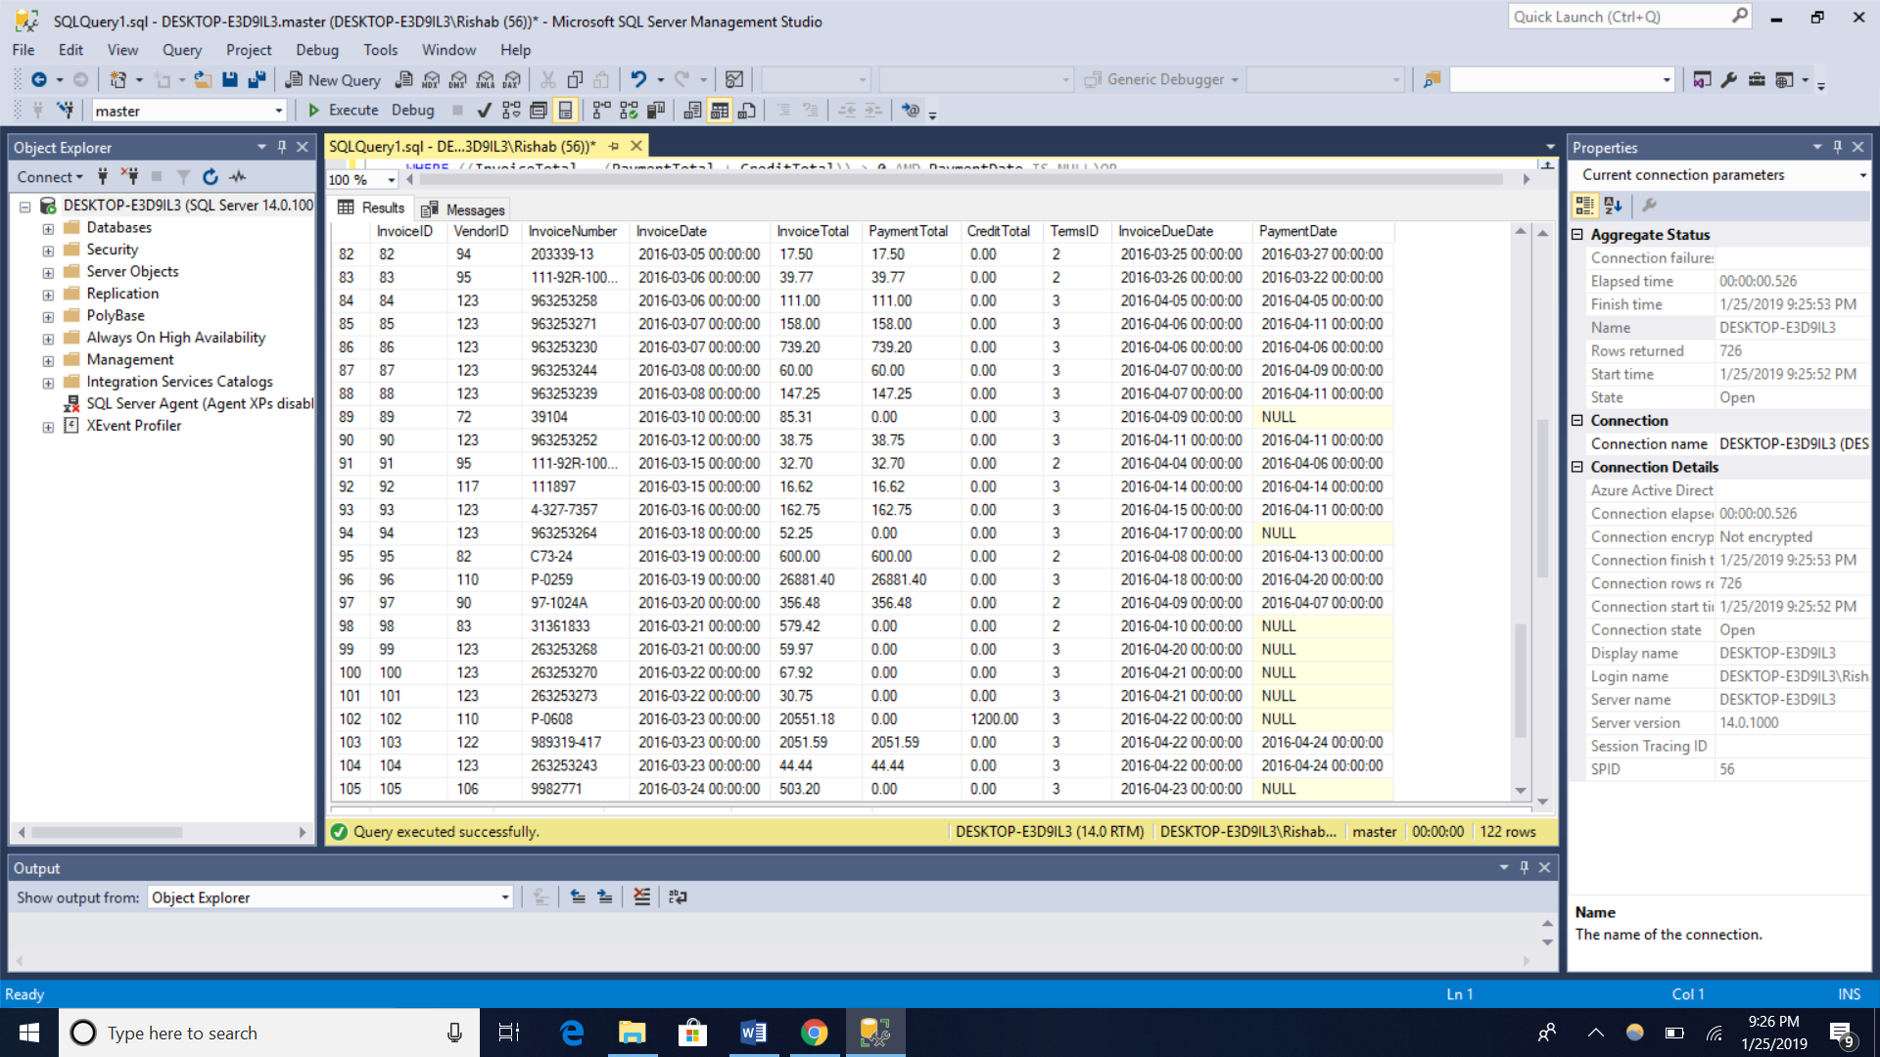(114 rows affected)

/*Q5*/

SELECT VendorName, VendorZipCode, DefaultAccountNo,AccountDescription

FROM AP.dbo.Vendors AS v JOIN AP.dbo.GLAccounts AS g

ON v.DefaultAccountNo = g.AccountNo

WHERE g.AccountDescription = 'Computer Equipment'

ORDER BY v.VendorName;

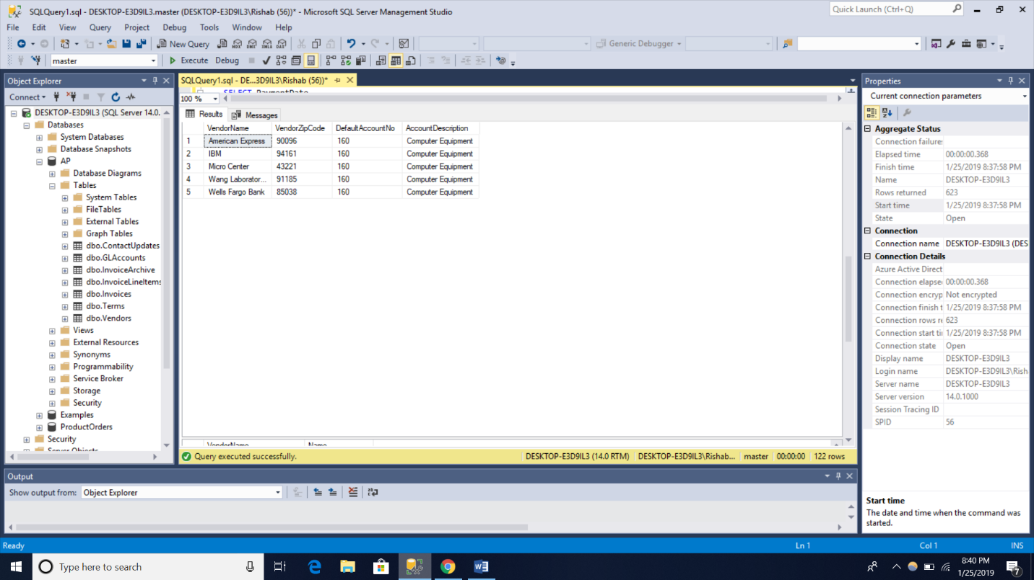

(5 rows affected)

/*Q6*/

SELECT DISTINCT Vendors1.VendorName, Vendors1.VendorContactLName + ',' + Vendors1.VendorContactFName AS Name

FROM AP.dbo.Vendors AS Vendors1 JOIN AP.dbo.Vendors AS Vendors2

ON Vendors1.VendorContactLName = Vendors2.VendorContactLName

ORDER BY Vendors1.VendorName;

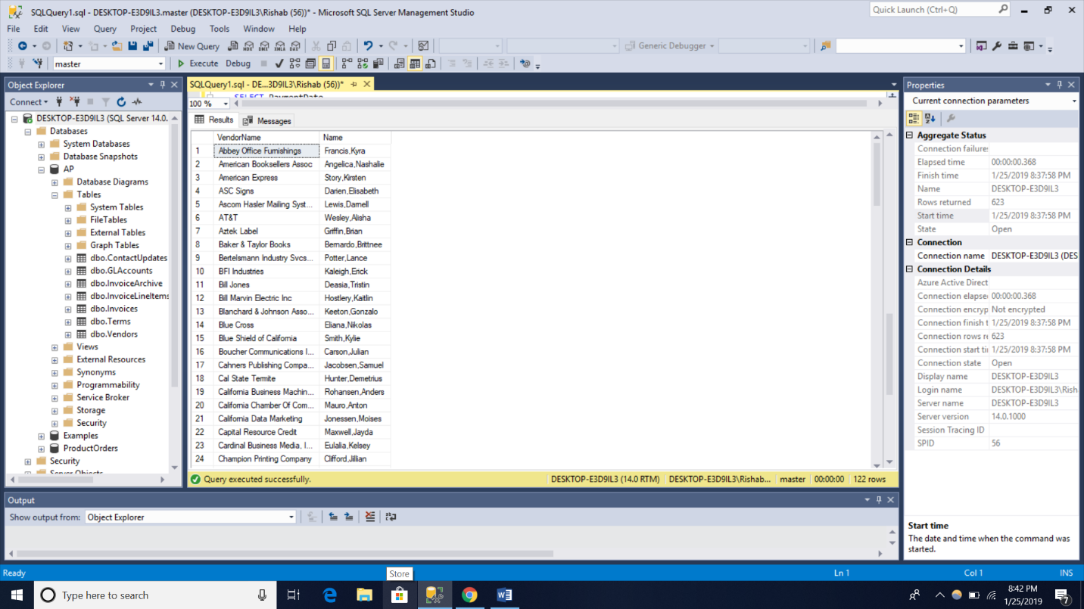

(122 rows affected)

/*Q7*/

SELECT VendorName, 'Outside NY' AS VendorState

FROM AP.dbo.Vendors

WHERE VendorState != 'NY'

UNION

SELECT VendorName, 'NY' AS VendorState

FROM AP.dbo.Vendors

WHERE VendorState = 'NY'

ORDER BY VendorName desc;

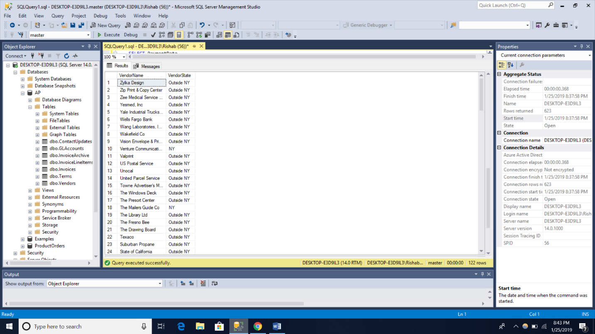

(122 rows affected)

/*Q8*/

SELECT g.AccountNo, g.AccountDescription

FROM AP.dbo.GLAccounts AS g LEFT JOIN AP.dbo.InvoiceLineItems AS i

ON g.AccountNo = i.AccountNo

WHERE i.AccountNo IS NULL

ORDER BY g.AccountNo;

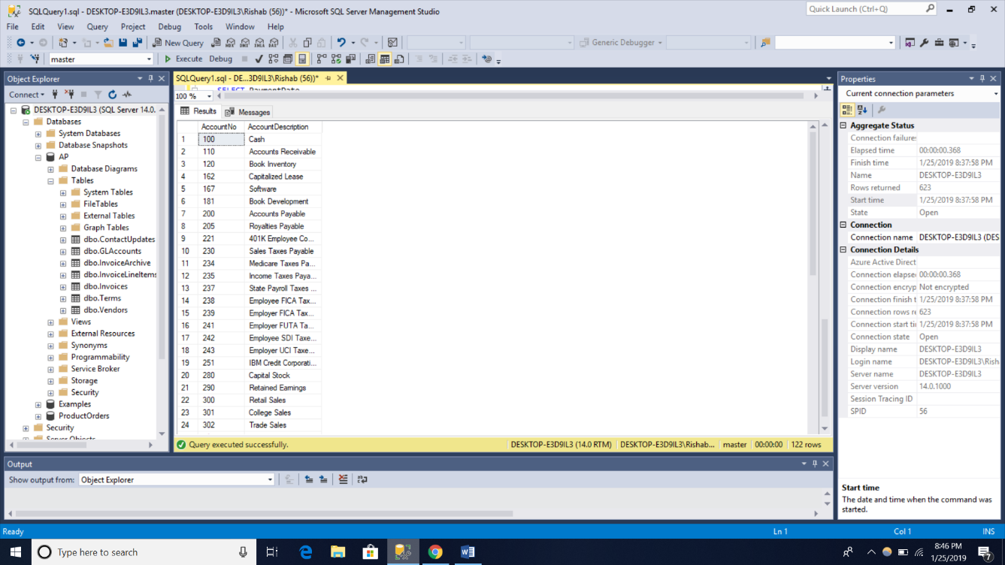

(54 rows affected)

RESULTS:

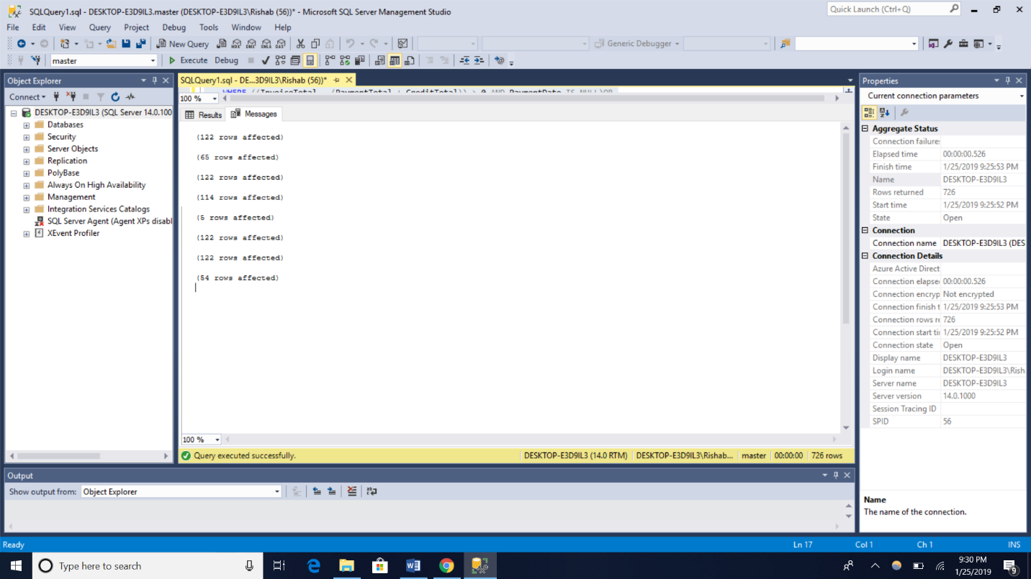

Remarks:

I learnt all the different parameters used with SELECT statement. I had problem in figuring out how to change content as ‘Outside NY’ but figured out using internet and some google search.

Knowledge of different types of JOIN was very useful.